**Test Automation Lab**

**Name: Aanchal Tailwal**

**Branch: BTech CSE**

**Batch: DevOps B-4**

**Sap Id: 500097386**

**Experiment 1**

**Invoking the WebPage via WebDriver in Java Demonstration**

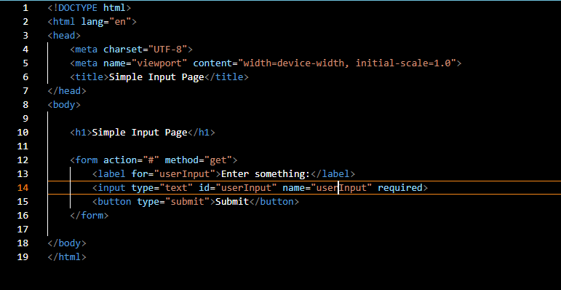

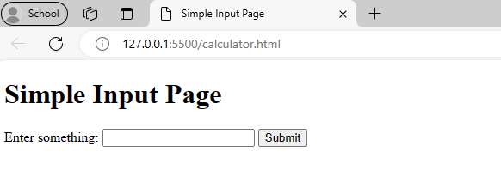

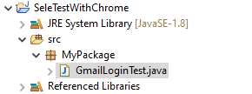

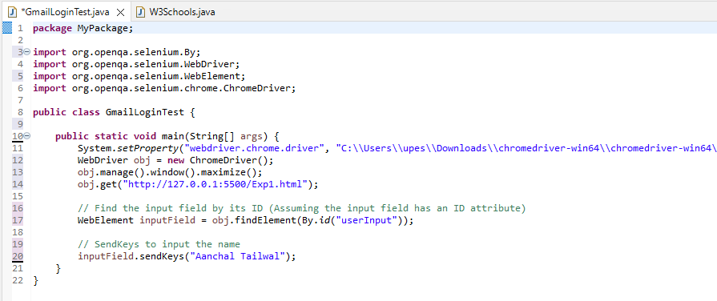

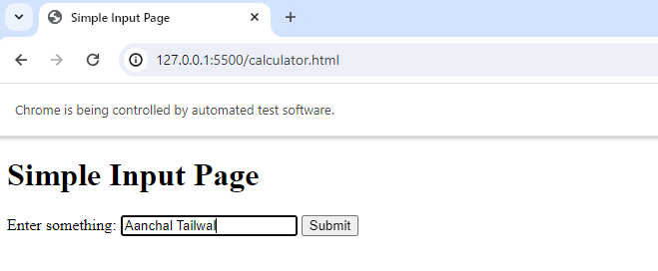

**Experiment 2**

**Usability Testing Questionnaire**

Task 1: Currency Converter

**Step:1 Creating a Web application Currency Converter**

* **HTML file**

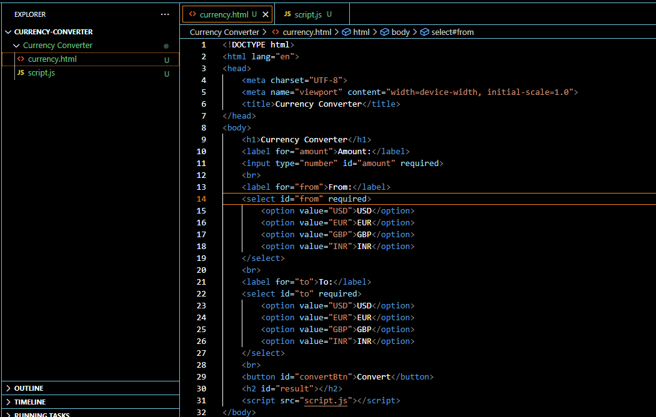

* **JavaScript**

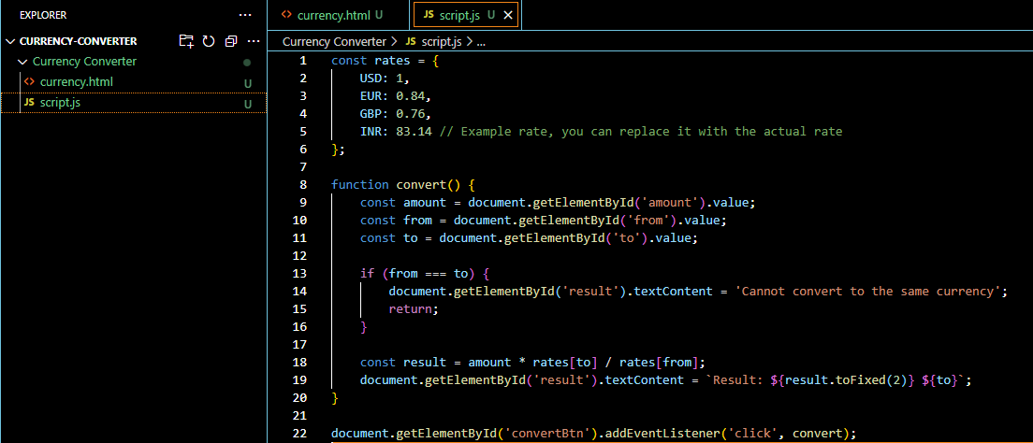

**Step:2 Output**

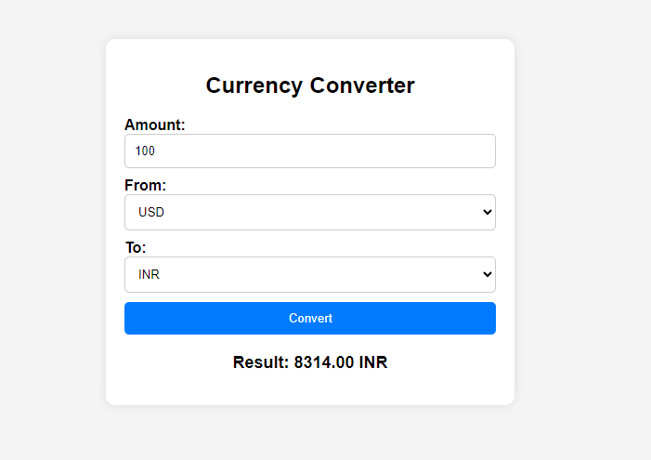

Task 2: Usability Testing

**Step:1 Creating a Feedback Form using Survey Planet**

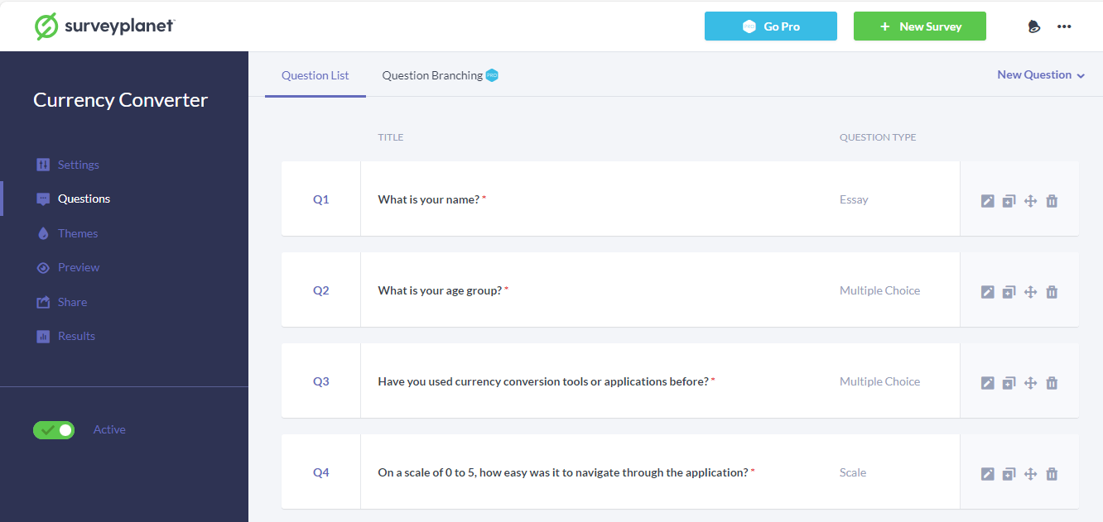

**Step:2 Form Template**

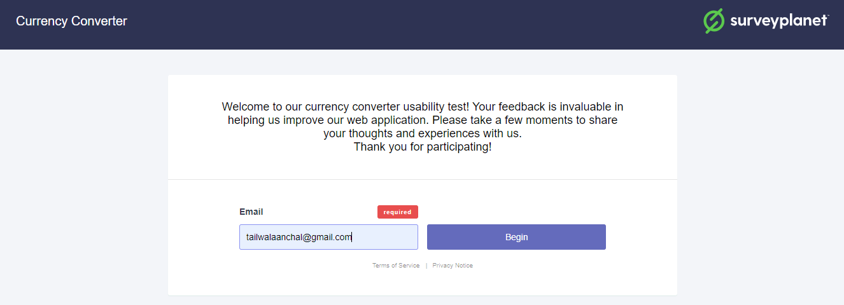

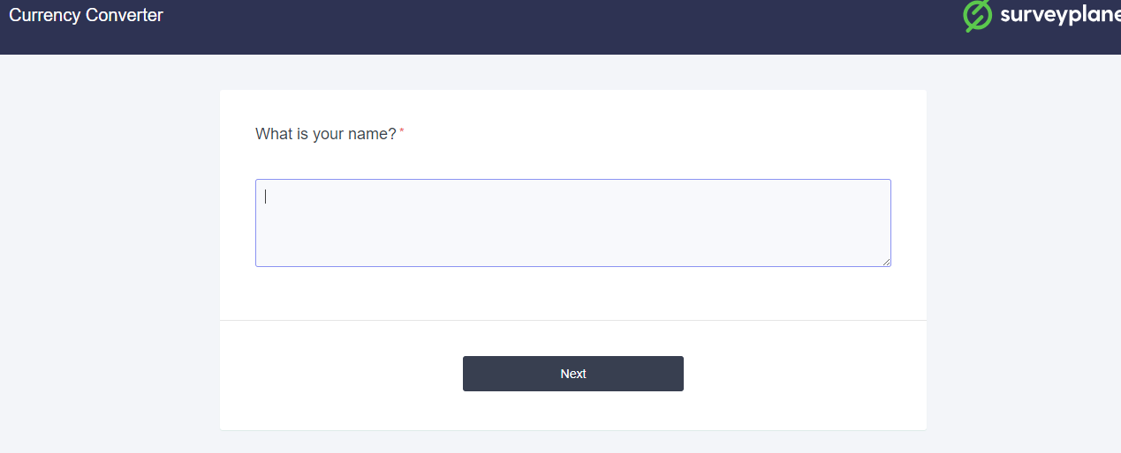

**Step:3 Results**

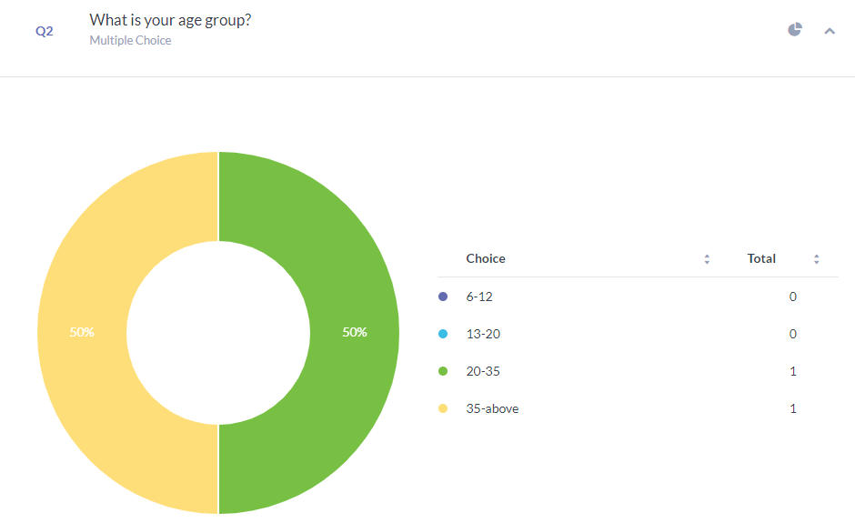

**Experiment 3**

**Usability Testing Report Generation**

# Currency Converter Test

**Aanchal Tailwal**

**5th Feb 2024**

## Table of Contents

1. Introduction

2. Executive Summary

3. Methodology

- Sessions

- Participants

4. Evaluation Tasks/Scenarios

5. Results

- Task Completion Success Rate

- Overall Metrics

- Likes, Dislikes, Participant Recommendations

- Recommendations

6. Conclusion

7. Attachments

- Attachment A: Background Questionnaire

## Introduction

Introduction:

Our currency converter web application serves as a user-friendly tool for quickly converting between different currencies. Its purpose is to provide users with a convenient way to perform currency conversions accurately and efficiently. This usability test aims to evaluate how effectively our interface facilitates users in completing routine currency conversion tasks. Participants will be asked to perform a series of common tasks using the application. Session recordings will be analyzed to identify areas for improvement and enhance the user experience of our web application.

The usability test for our currency converter web application was conducted online by the moderator, Aanchal Tailwal. There were six participants involved in the session. The test was conducted remotely using web conferencing software. The moderator guided participants through a series of tasks while observing their interactions with the application. Session data included participants' navigational choices, task completion rates, comments, overall satisfaction ratings, questions, and feedback.

## Executive Summary

The usability test for our currency converter web application was conducted online by the moderator on 5th Feb 2024. Six participants took part in the session, which was conducted remotely via web conferencing software. The purpose of the test was to evaluate the usability of the currency converter interface and identify any areas for improvement in terms of user experience.

Each session lasted approximately for 10-15 min, during which participants were guided through a series of tasks to assess their interaction with the application. Overall, participants found the currency converter web application to be user-friendly, with 80% reporting that the application was easy to use.

Key findings from the usability test included:

- Ease of navigation was rated highly.

- The currency conversion process was found to be straightforward.

- Participants expressed satisfaction with the design and layout of the application.

- Some participants reported encountering technical issues.

- All participants found the provided currency exchange rates to be accurate.

- Most participants indicated they would recommend the currency converter application to others.

- Feedback for improvement was generally positive, with specific suggestions not provided by most participants. However, one participant suggested shutting down the app.

This document contains detailed feedback from participants, including satisfaction ratings, task completion rates, ease or difficulty of completion ratings, time on task, errors, and recommendations for improvements. Additionally, scenarios and questionnaires used during the test are included in the Attachments section for reference.

## Methodology

### Sessions

Participants for the usability testing of the currency converter web application were selected by our teacher for our class assessment. Each individual session lasted approximately 10-15 minutes. Before the session, I explained to participants how the test would proceed and what they would be asked to do.

### During the session, participants were asked to use the currency converter web application and perform various tasks such as converting currencies, navigating through the application, and providing feedback on their experience.

### After the session, participants were asked a series of questions to gather feedback on their experience using the application. I prepared a form with a set of questions, and participants were asked to respond to these questions based on their interaction with the application during the testing session.

### The post-session questions included aspects such as ease of use, navigation, satisfaction with the design/layout, any technical issues encountered, accuracy of exchange rates, likelihood of recommending the application to others, and any additional feedback or suggestions for improvement.

### Participants were encouraged to provide detailed feedback to help identify areas for improvement in the currency converter application.

### Participants

All participants were students enrolled in BTech CSE/ DevOps B4.

Six participants were scheduled for the usability testing sessions. All six participants completed the test.

**Role**

| **Participant** | **Name** | **Age Group** | **Gender** | | **Previous Experience with Currency Conversion Tools** |  |
| --- | --- | --- | --- | --- | --- | --- |
| 1  2  3  4  5  6 | Shashank Saurabh  Aakshita Singh  Abhinav Kumar  Yadrishi Dixit  Shivam Singh  Shivam Kumar | 20-35  20-35  20-35  20-35  20-35  20-35 | Male  Female  Male  Female  Male  Male | Yes  Yes  No  Yes  No  Yes | | -  -  -  -  -  - |

### Evaluation Tasks/Scenarios

The task scenarios were created by Moderator Aanchal Tailwal. Participants were asked to complete the following tasks:

- Convert USD to EUR.

- Convert EUR to GBP.

- Convert GBP to INR.

- Convert USD to GBP.

- Convert USD to INR.

- Convert GBP to EUR.

- Convert INR to EUR.

These tasks were designed to evaluate the participants' ability to use the currency converter web application to perform currency conversions accurately and efficiently.

## Results

### Task Completion Success Rate

All participants successfully completed Task 1 (convert USD to EUR) and Task 2 (convert EUR to INR). Six out of six participants (100%) completed Task 3 (convert INR to GBP), Task 4 (convert GBP to USD), and Task 5 (convert USD to EUR). Task 6 (convert EUR to GBP) also had a completion rate of 100%.

Task Ratings:

Ease in Finding Information:

Participants found it easy to complete all tasks, with a mean agreement rating ranging from 4.0 to 4.7.

Keeping Track of Location in Site:

All participants found it easy to keep track of their location while completing all tasks, with a mean agreement rating ranging from 4.0 to 4.7.

Predicting Information Section:

Participants found it easy to predict which section of the website contained the information for all tasks, with a mean agreement rating ranging from 4.3 to 4.7.

**Test 1 – Mean Task Ratings & Percent Agree**

| **Task** | **Ease – Finding Info** | **Location in Site** | **Predict Section** | **Overall** |
| --- | --- | --- | --- | --- |
| 1 – Convert USD to EUR | 4.7 (100%) | 4.7 (100%) | 4.7 (100%) | 4.7 |
| 2 – Convert EUR to INR | 4.7 (100%) | 4.7 (100%) | 4.7 (100%) | 4.7 |
| 3 – convert INR to GBP | 4.7 (100%) | 4.7 (100%) | 4.7 (100%) | 4.7 |
| 4 – convert GBP to USD | 4.7 (100%) | 4.7 (100%) | 4.7 (100%) | 4.7 |
| 5 – convert USD to EUR | 4.7 (100%) | 4.7 (100%) | 4.7 (100%) | 4.7 |
| 6 – convert EUR to GBP | 4.7 (100%) | 4.7 (100%) | 4.7 (100%) | 4.7 |

*\*Percent Agree (%) = Agree & Strongly Agree Responses combined*

Time on Task:

- Task 1 (Convert USD to EUR): Participants spent an average of 82 seconds completing this task, with completion times ranging from 50 to 310 seconds.

- Task 2 (Convert EUR to INR): Participants spent an average of 200 seconds completing this task, with completion times ranging from 50 to 390 seconds.

- Task 3 (Convert INR to GBP): Participants spent an average of 67 seconds completing this task, with completion times ranging from 15 to 215 seconds.

- Task 4 (Convert GBP to USD): Participants spent an average of 129 seconds completing this task, with completion times ranging from 55 to 240 seconds.

- Task 5 (Convert USD to EUR): Participants spent an average of 69 seconds completing this task, with completion times ranging from 29 to 127 seconds.

- Task 6 (Convert EUR to GBP): Participants spent an average of 210 seconds completing this task, with completion times ranging from 110 to 465 seconds.

Errors:

The number of errors participants made while trying to complete the task scenarios was captured by the moderator.

Task 4 (Convert GBP to USD) had the most errors, with participants making a total of 9 errors. Task 2 (convert EUR to GBP) also had a high number of errors, with participants making a total of 10 errors. However, all errors made were non-critical and did not prevent successful completion of the scenarios.

| **Task** | **Task Completion** | **Errors** | **Time on Task** | **Satisfaction\*** |
| --- | --- | --- | --- | --- |
| **1** | 6 | 2 | 87 | 4.33 |
| **2** | 6 | 10 | 102 | 6.37 |
| **3** | 6 | 3 | 75 | 4.00 |
| **4** | 6 | 9 | 120 | 3.33 |
| **5** | 6 | 2 | 90 | 4.33 |
| **6** | 6 | 4 | 150 | 6.00 |

### Overall Metrics

After completing the task sessions, participants rated the currency converter web application for eight overall measures. The highest percent of 'agreed' satisfaction ratings were as follows:

Most participants (85%) agreed that they would use the currency converter application frequently.

The majority of participants (77%) agreed that they could get currency conversion information quickly.

Participants generally agreed (62%) that the website was well-organized.

However, the variables that received the lowest satisfaction ratings were:

Only 54% of participants agreed that the homepage's content made them want to explore the site.

A low percentage (8%) of participants found it difficult to keep track of where they were in the application.

*\*Percent Agree (%) = Agree & Strongly Agree Responses combined*

**Recommendations for Improvement**

No need to improve

No

No

Shut your app down

No all good

## Recommendations

The recommendations section offers suggestions for enhancing the user experience based on participant feedback, behaviors, and success rates. Each recommendation is accompanied by a severity rating. These recommendations aim to enhance overall usability and address areas where participants encountered difficulties or confusion with the interface and information architecture.

**For example:**

**Find Organizational or Individual Funding Information (Task 2)**

Task 2 required participants to find organization funding (Test 1) or individual funding (Test 2).

| **Change** | **Justification** | **Severity** |
| --- | --- | --- |
| * Add categories to funding pages * Add additional descriptive text | Participants rated the ease of finding funding information poorly, indicating a lack of clarity and organization. Categorizing funding opportunities will enhance navigation.  By adding descriptive text on the funding opportunities homepage, users will have clearer guidance on the types of funding available, improving overall usability. | High  High |

## Conclusion

Overall, participants expressed positive feedback regarding the currency converter web application, highlighting its ease of use and accurate currency exchange rates. The majority of participants indicated they would use the application frequently and found it easy to navigate. However, there were areas for improvement identified, particularly regarding the clarity of funding information. Implementing the recommended changes, such as adding categories to funding pages and providing additional descriptive text, can enhance the overall user experience. Continuous collaboration with users will ensure that the application remains user-centered and addresses evolving user needs.

Attachments:

- Attachment A: Background Questionnaire

<https://s.surveyplanet.com/xpyokxfq>

**Experiment 4**

**Getting Introduced to Test NG framework**

Task1: Creating Test cases and run it using TESTNG Framework

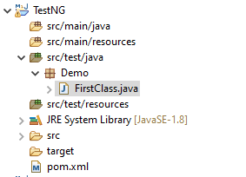

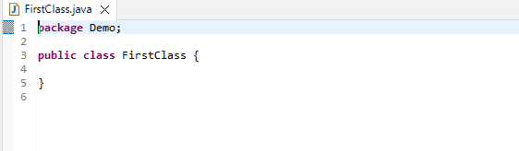



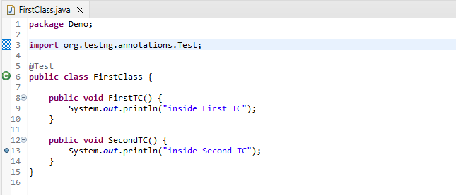

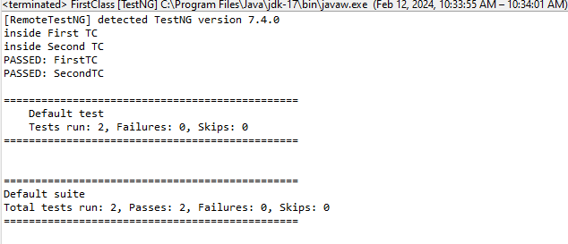

Task2: Creating Testing.XML and running it using TestNG framework

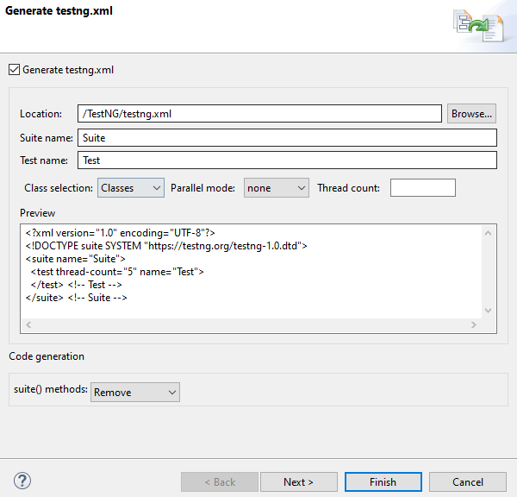

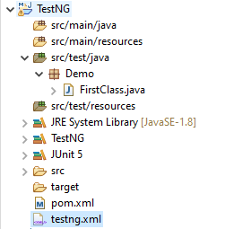

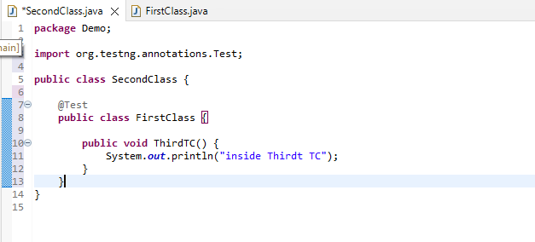

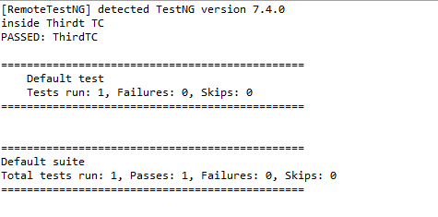

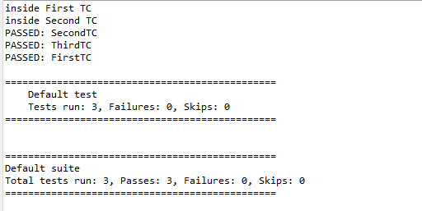

**Experiment 5**

**Mid Semester Assessment**

**Experiment 6**

Task1: Create a Web application for stateless Login Checking

Task2: Create test-case to check the application using TestNG & Selenium

**Experiment 7**

Traversing through a Tutorial Website

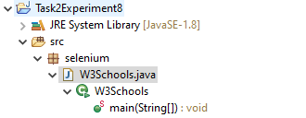

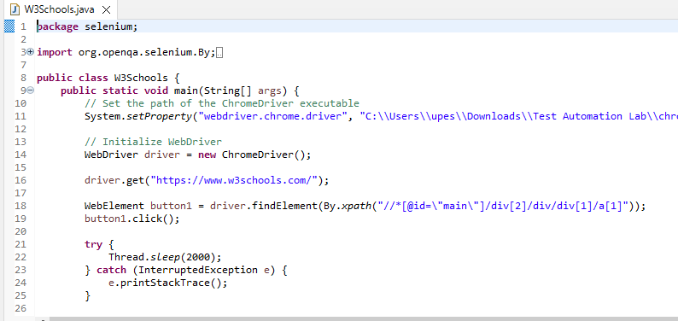

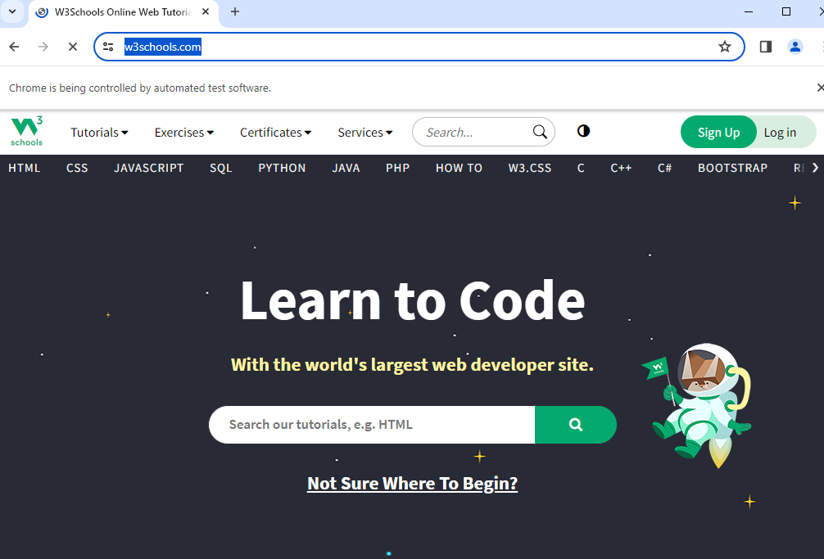

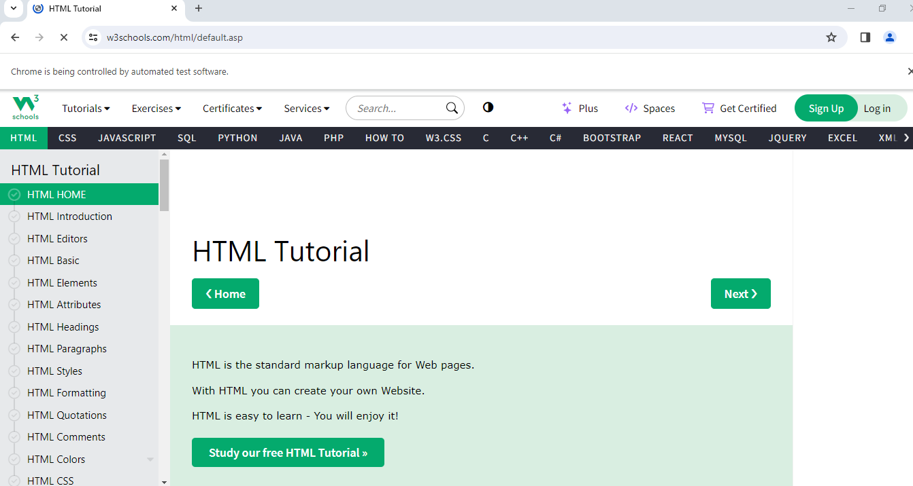

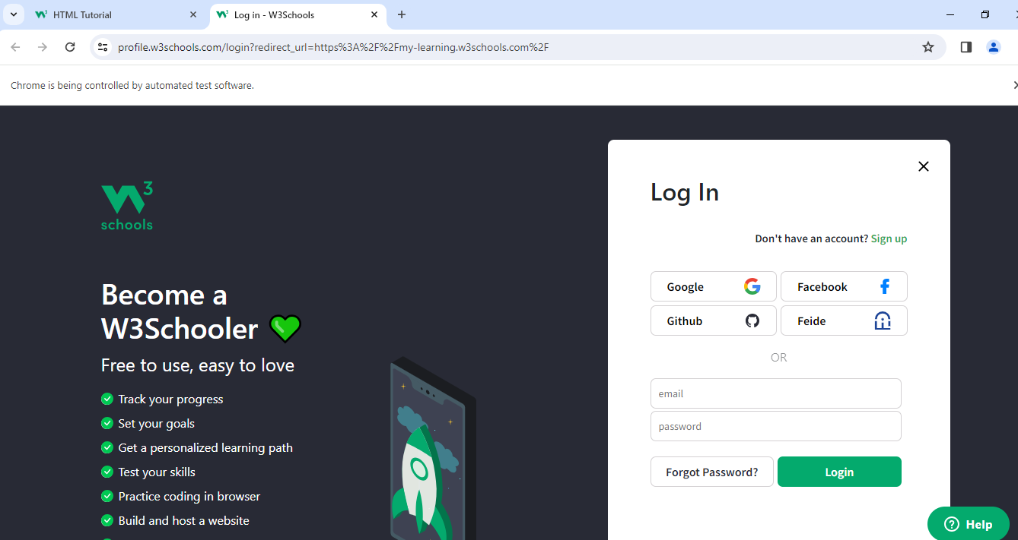

**Experiment 8**

Test Automating the Calculator Application

Task 1: Create a web application(home.html) using JS to add/sub/mul/del nos.(2 number boxes, where 2 for input and one for output when a button is clicked)

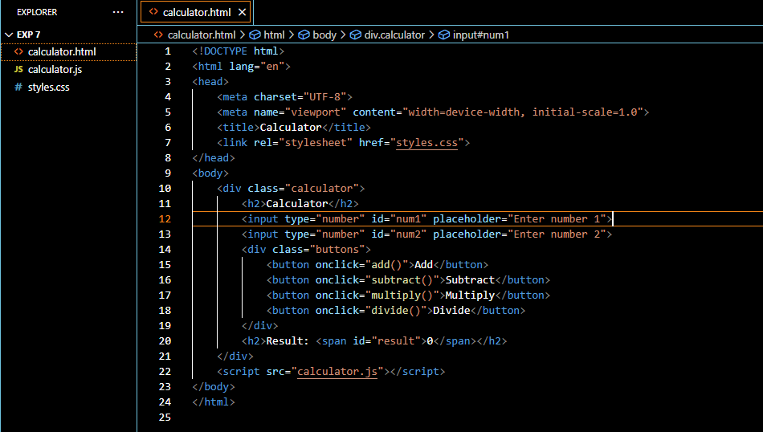

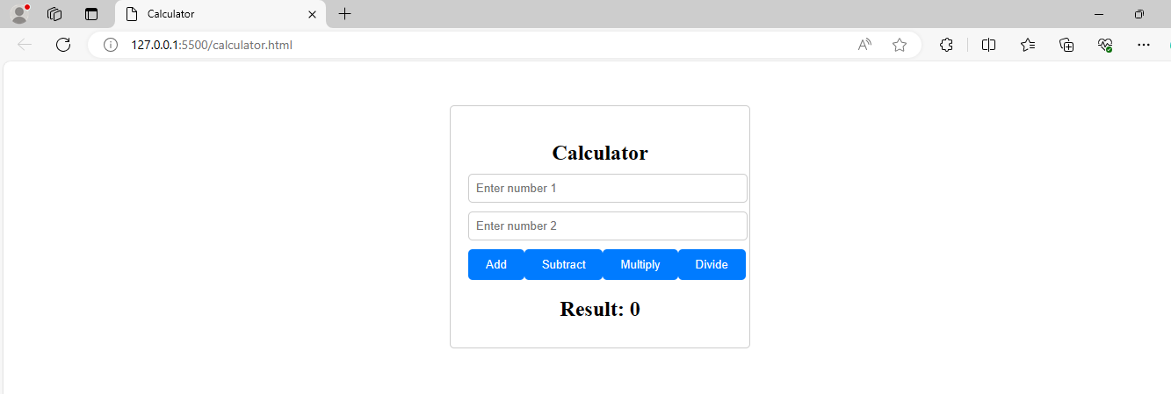

Task 2: Create a maven project where the PSVM will open the web application using selenium

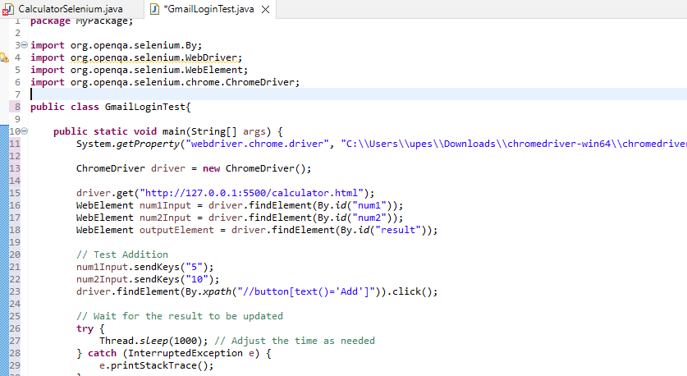

Task 3:Now automate the testing process. Send keys to t1 and t2 and obtain the value and check if the values are correct as your test case. without using TestNG

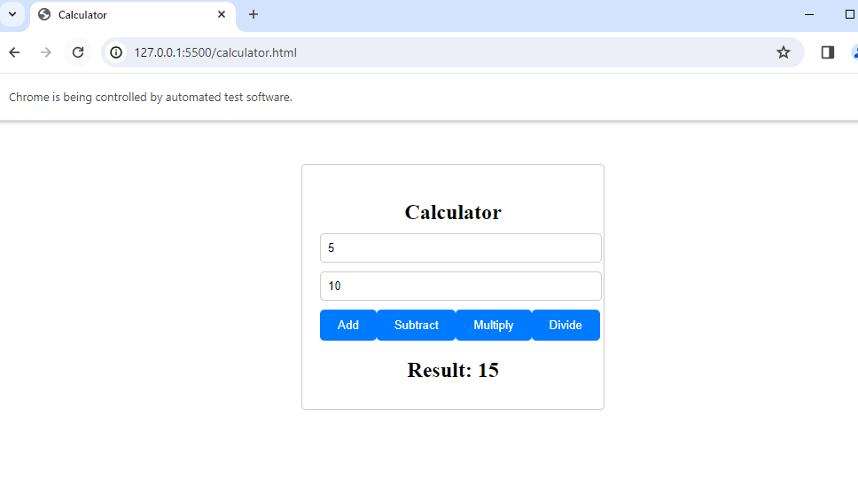



**Experiment 9**

Working on XPath Selector

Step 1: Open gmail.com

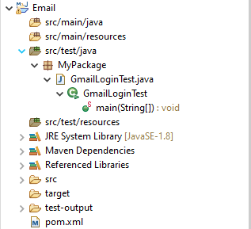

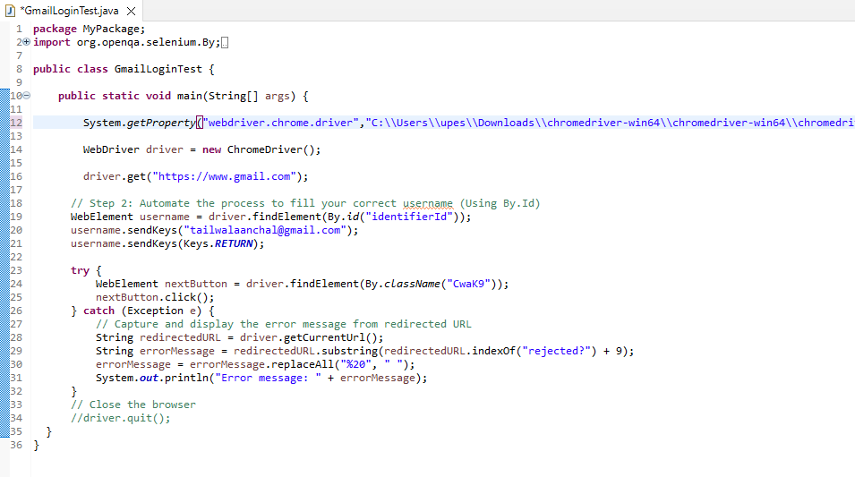

Step 2: Automate the process to fill an incorrect username(Using By.Id)

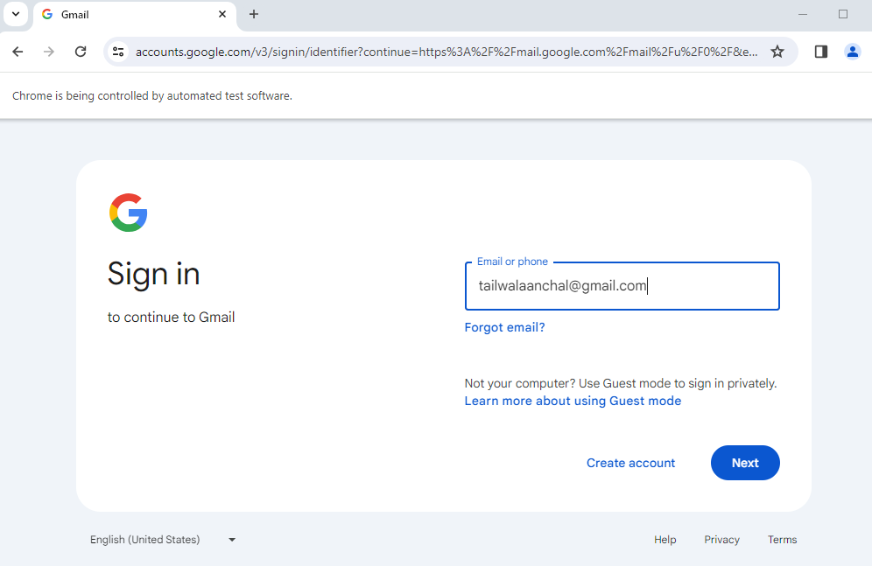

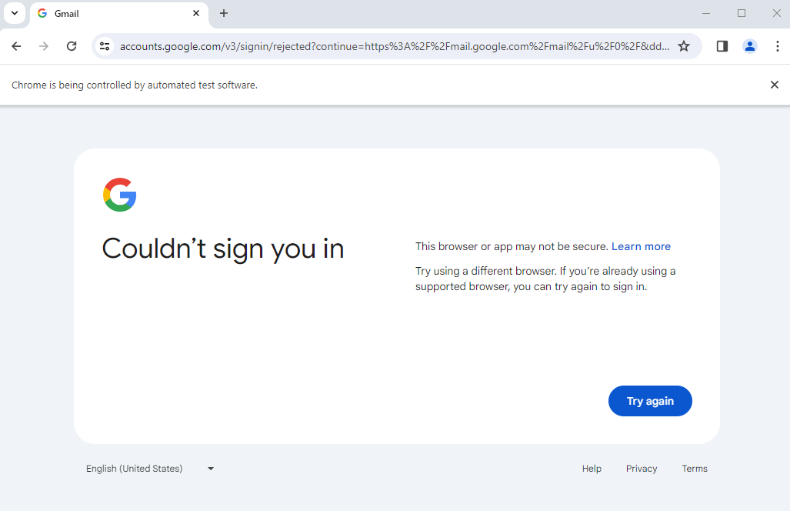

Step 3: Automated Click(Using By.className)

